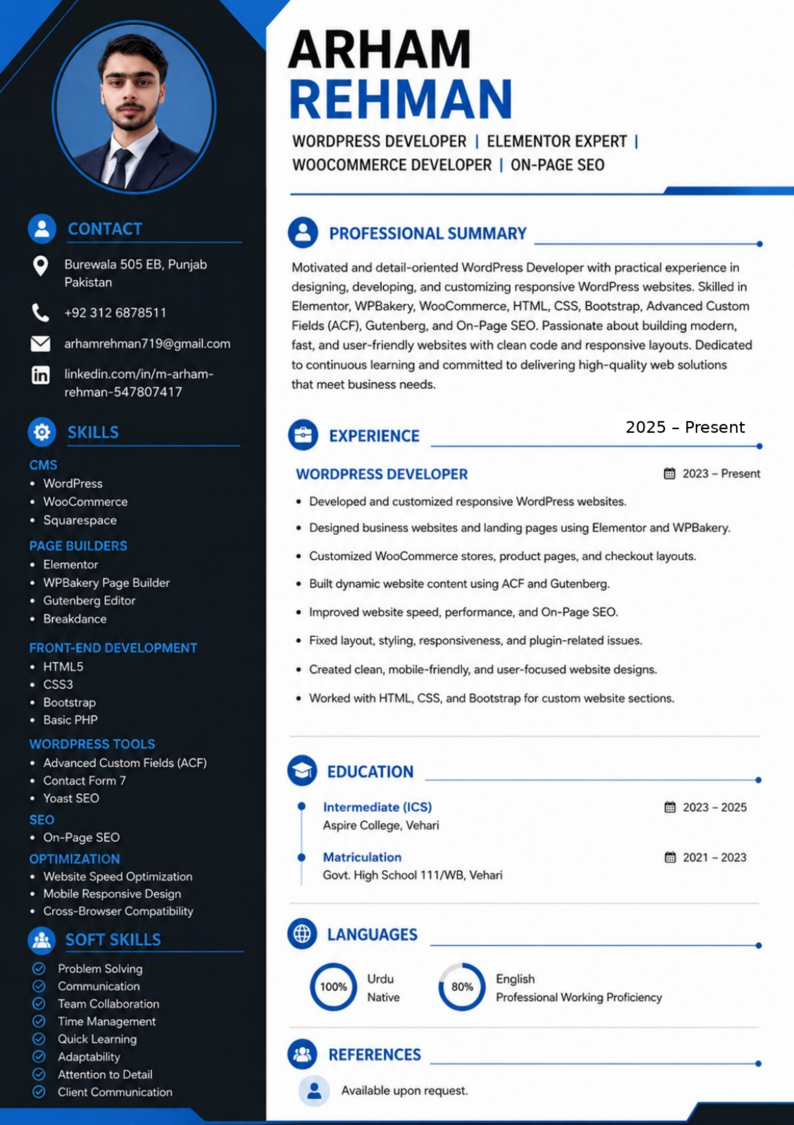

ARHAM REHMAN — CV TEXT VERSION
e A hl a ia mn | A
WORDPRESS DEVELOPER | ELEMENTOR EXPERT |
WOOCOMMERCE DEVELOPER | ON-PAGE SEO
a CONTACT - PROFESSIONAL SUMMARY
9 Burewala 505 EB, Punjab Motivated and detail-oriented WordPress Developer with practical experience in
Pakistan designing, developing, and customizing responsive WordPress websites. Skilled in
. 492 312 6878511 Elementor, WPBakery, WooCommerce, HTML, CSS, Bootstrap, Advanced Custom
Fields (ACF), Gutenberg, and On-Page SEO. Passionate about building modern,
B% arhamrehman719@gmail.com fast, and user-friendly websites with clean code and responsive layouts. Dedicated
in| nitedinieohvik/nearhern to continuous learning and committed to delivering high-quality web solutions
rehman-5478074 17 that meet business needs.
@ skis -) EXPERIENCI 2025 ~ Present
* WordPress WORDPRESS DEVELOPE! 2023 - Present
¢ WooCommerce ¢ Developed and customized responsive WordPress websites.
* Squarespace ¢ Designed business websites and landing pages using Elementor and WPBakery.
PAGE BUILDERS ;
» iE lertthtor ¢ Customized WooCommerce stores, product pages, and checkout layouts.
¢ WPBakery Page Builder ¢ Built dynamic website content using ACF and Gutenberg.
e Gutenberg Editor
5 Rieelclarice ¢ Improved website speed, performance, and On-Page SEO.
FRONT-END DEVELOPMENT e Fixed layout, styling, responsiveness, and plugin-related issues.
¢ HTML5 ¢ Created clean, mobile-friendly, and user-focused website designs.
¢ CSS3
* Bootstrap ¢ Worked with HTML, CSS, and Bootstrap for custom website sections.
e Basic PHP
WORDPRESS TOOLS
e Advanced Custom Fields (ACF) Qe Pe ee
ey EDUCATION
¢ Contact Form 7 y
¢ Yoast SEO r ae
Intermediate (ICS) 2023 - 2025
SEO Aspire College, Vehari
¢ On-Page SEO
OPTIMIZATION ) Matriculation 2021 - 2023
¢ Website Speed Optimization Govt. High School 111/WB, Vehari
¢ Mobile Responsive Design
¢ Cross-Browser Compatibility
@ sort skitts Ki) LANGUAGES ;
© Problem Solving fi" ~ ;
© Communication 100% J ane q 80% J —
© TeamCollaboration Native g Professional Working Proficiency
© Time Management
© Quick Learning ~~
Q Adaptability t REFERENCES
2 Attention to Detail a3
© Client Communication iS Available upon request.

